Software requirement specification (SRS) document template



Review history



Approval history

By: Shafeen Chowdhury



Revision history

Project name: Mechatronic Solution and Documentation

Version: 01

|  |  |  |  |
| --- | --- | --- | --- |
| Version | Author | Verson description | Date completed |
|  |  |  |  |

|  |  |  |  |
| --- | --- | --- | --- |
| Approving party | Version approved | Signature | Date |
|  |  |  |  |
|  |  |  |  |
|  |  |  |  |
|  |  |  |  |

|  |  |  |  |
| --- | --- | --- | --- |
| Reviewer | Version reviewed | Signature | Date |
|  |  |  |  |
|  |  |  |  |
|  |  |  |  |
|  |  |  |  |

# Table of contents



1. Introduction
   1. Product scope
   2. Product value
   3. Intended audience
   4. Intended use
   5. General description

2 Functional requirements

1. External interface requirements
   1. User interface requirements
   2. Hardware interface requirements
   3. Software interface requirements
   4. Communication interface requirements
2. Non-functional requirements
   1. Security
   2. Capacity
   3. Compatibility
   4. Reliability
   5. Scalability
   6. Maintainability
   7. Usability
   8. Other non-functional requirements

5 Definitions and acronyms



1

Introduction

Describe the purpose of the document.

* 1. Product scope

List the benefits, objectives, and goals of the product.

The objective of BT-896 (Robot) is to have the ability to solve a maze whilst identifying the benefits of BT-896 is the industrial setting. Overall, the goal of Kettle chili chips is to solve a maze with the harsh environment.

* 1. Product value

Describe how the audience will find value in the product.

The target audience will find value in this product due to usage and opportunities. BT – 896 can be applied to many different aspects which can eventually expand to automating certain everyday task

* 1. Intended audience

Write who the product is intended to serve.

The target market in which we will value this product is keen on engineering, more specifically robotics engineering

* 1. Intended use

Describe how will the intended audience use this product.

The intended use for clank is to solve and identify obstacles in a maze but can be used for different problems. This may include moving blocks identifying different colors.

* 1. General description

Give a summary of the functions the software would perform and the features to be included.

The product will follow a track in a specific maze whilst clearing obstacles on its way but using the wheels for direction and the other parts which allow the product to maneuver over these obstacles such like different colored titles ect.

# Functional requirements



2

List the design requirements, graphics requirements, operating system requirements, and constraints of the product.

The robot must be designed with durability, performance to ensure reliable operation, this including assembling all compiled parts are correct, using durable components, ensuring the transmission is strong using a voltmeter, additionally, parts like the battery and lcd must be charged and up to date, as for the robot, the robot should withstand various environmental condition, each element contributes to the robots effectiveness, including its lifespan and risk of failure

External interface requirements



3

* 1. User interface requirements

Describe the logic behind the interactions between

the users and the software (screen layouts, style guides, etc).

The robots UI must be simple, responsive and can clearly communicate system status, this includes the LCD to indicate the robot’s status with the minimalistic layout and easy to read buttons and responsive feedback reducing user error and improving user experience

* 1. Hardware interface requirements

List the supported devices the software is intended

to run on, the network requirements, and the communication protocols to be used.

The robot must support specific hardware interfaces to ensure smooth integration and communication between components. These devices include the raspberry pi and ultrasonic sensors; communication should occur over I2C with net worth from local network.

* 1. Software interface requirements

Include the connections between your product and other software components, including frontend/backend framework, libraries, etc.

The robot’s software interface must support reliable development tools when handling data, through Visual studio code using python with libraries like (v.02), and must support connection between software and hardware, the backend must process data while the front end presents status updates

* 1. Communication interface requirements

List any requirements for the communication programs your product will use, like emails or embedded forms.

The robot’s communication interface must ensure reliable, secure and user-friendly data exchange between the user and system, including reliable data transmission, effective error reporting and secure communication protocols, effective error reporting ensuring that any problems are consistently sent and received.

# Non-functional requirements



4

* 1. Security

Include any privacy and data protection regulations that should be adhered to.

Ensuring the data is safe the robot must follow basic cybersecurity standards, and the use of secure connections ensures updating the software and safe data transfers. These steps ensure the risk of hacking is minimized and protects privacy

* 1. Capacity

Describe the current and future storage needs of your software.

The robot must have enough storage capacity to save and process data, by collecting the information as it navigates it stores it in its memory, allowing the robot to potentially optimize its route

* 1. Compatibility

List the minimum hardware requirements for your software.

The robot should meet the minimum hardware and software requirements to function effectively and properly, this includes the main components like a reliable battery, raspberry pi, and sensors to perform the basics.

* 1. Reliability

Calculate what the critical failure time of your product would be under normal usage.

Under normal usage the critical failure time of the robot system would be around 150 hours of continuous use.

* 1. Scalability

Calculate the highest workloads under which your software will still perform as expected.

The robot must be able to handle large and complex majors with losing performance, by efficiently can navigate 50 x 50 in size and adapt to complex layouts.

* 1. Maintainability

Describe how continuous integration should be used to deploy features and bug fixes quickly.

To ensure the robot works before it deploys and bugs can be fixed efficiently the code will undergo unit testing throughout each section before starting, ensuring that each part of the robot works properly.

* 1. Usability

Describe how easy it should be for end-users to use your software.

The robot should have user friendly UI in which provides clear feedback and can display error messages, have a responsive design which reacts quickly and smooth communication between each part of the robot to reduce the amount of bugs

* 1. Other

List any additional non-functional requirements.

The robot must meet the nonfunctional requirements to ensure safety and a reliable working robot, this includes environmental tolerance consistent reliability, high responsiveness and overall safety

Definitions and acronyms



5

|  |  |
| --- | --- |
| OOP | A programming paradigm that organizes software design around data, or objects, rather than logic and function |
| I2C | Inter-Integrated Circuit |
| UI | User-interface |
| LCD | Liquid-crystal display |
| Voltmeter | to measure voltage in electrical circuits or electronic devices |
| Battery | A device that produces electricity |
|  |  |
|  |  |
|  |  |
|  |  |
|  |  |
|  |  |
|  |  |
|  |  |
|  |  |
|  |  |
|  |  |
|  |  |
|  |  |
|  |  |
|  |  |
|  |  |
|  |  |

Micro Python OOP Pi Pico Mini Project

Research and planning

This consists of the diagrams, including UML class diagram, DFD, flowchart, wiring diagram

**UML Class Diagram**

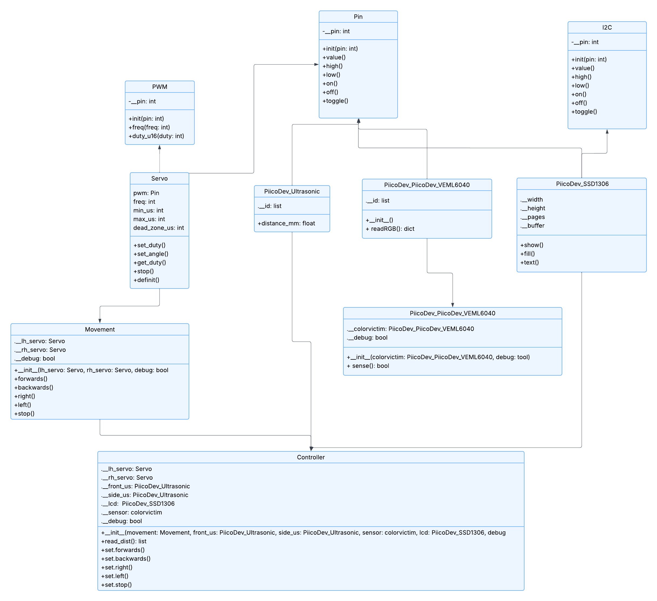

**Data Flow Diagrams**

Data flow diagram 0:

Data flow diagram 1:

Flowchart

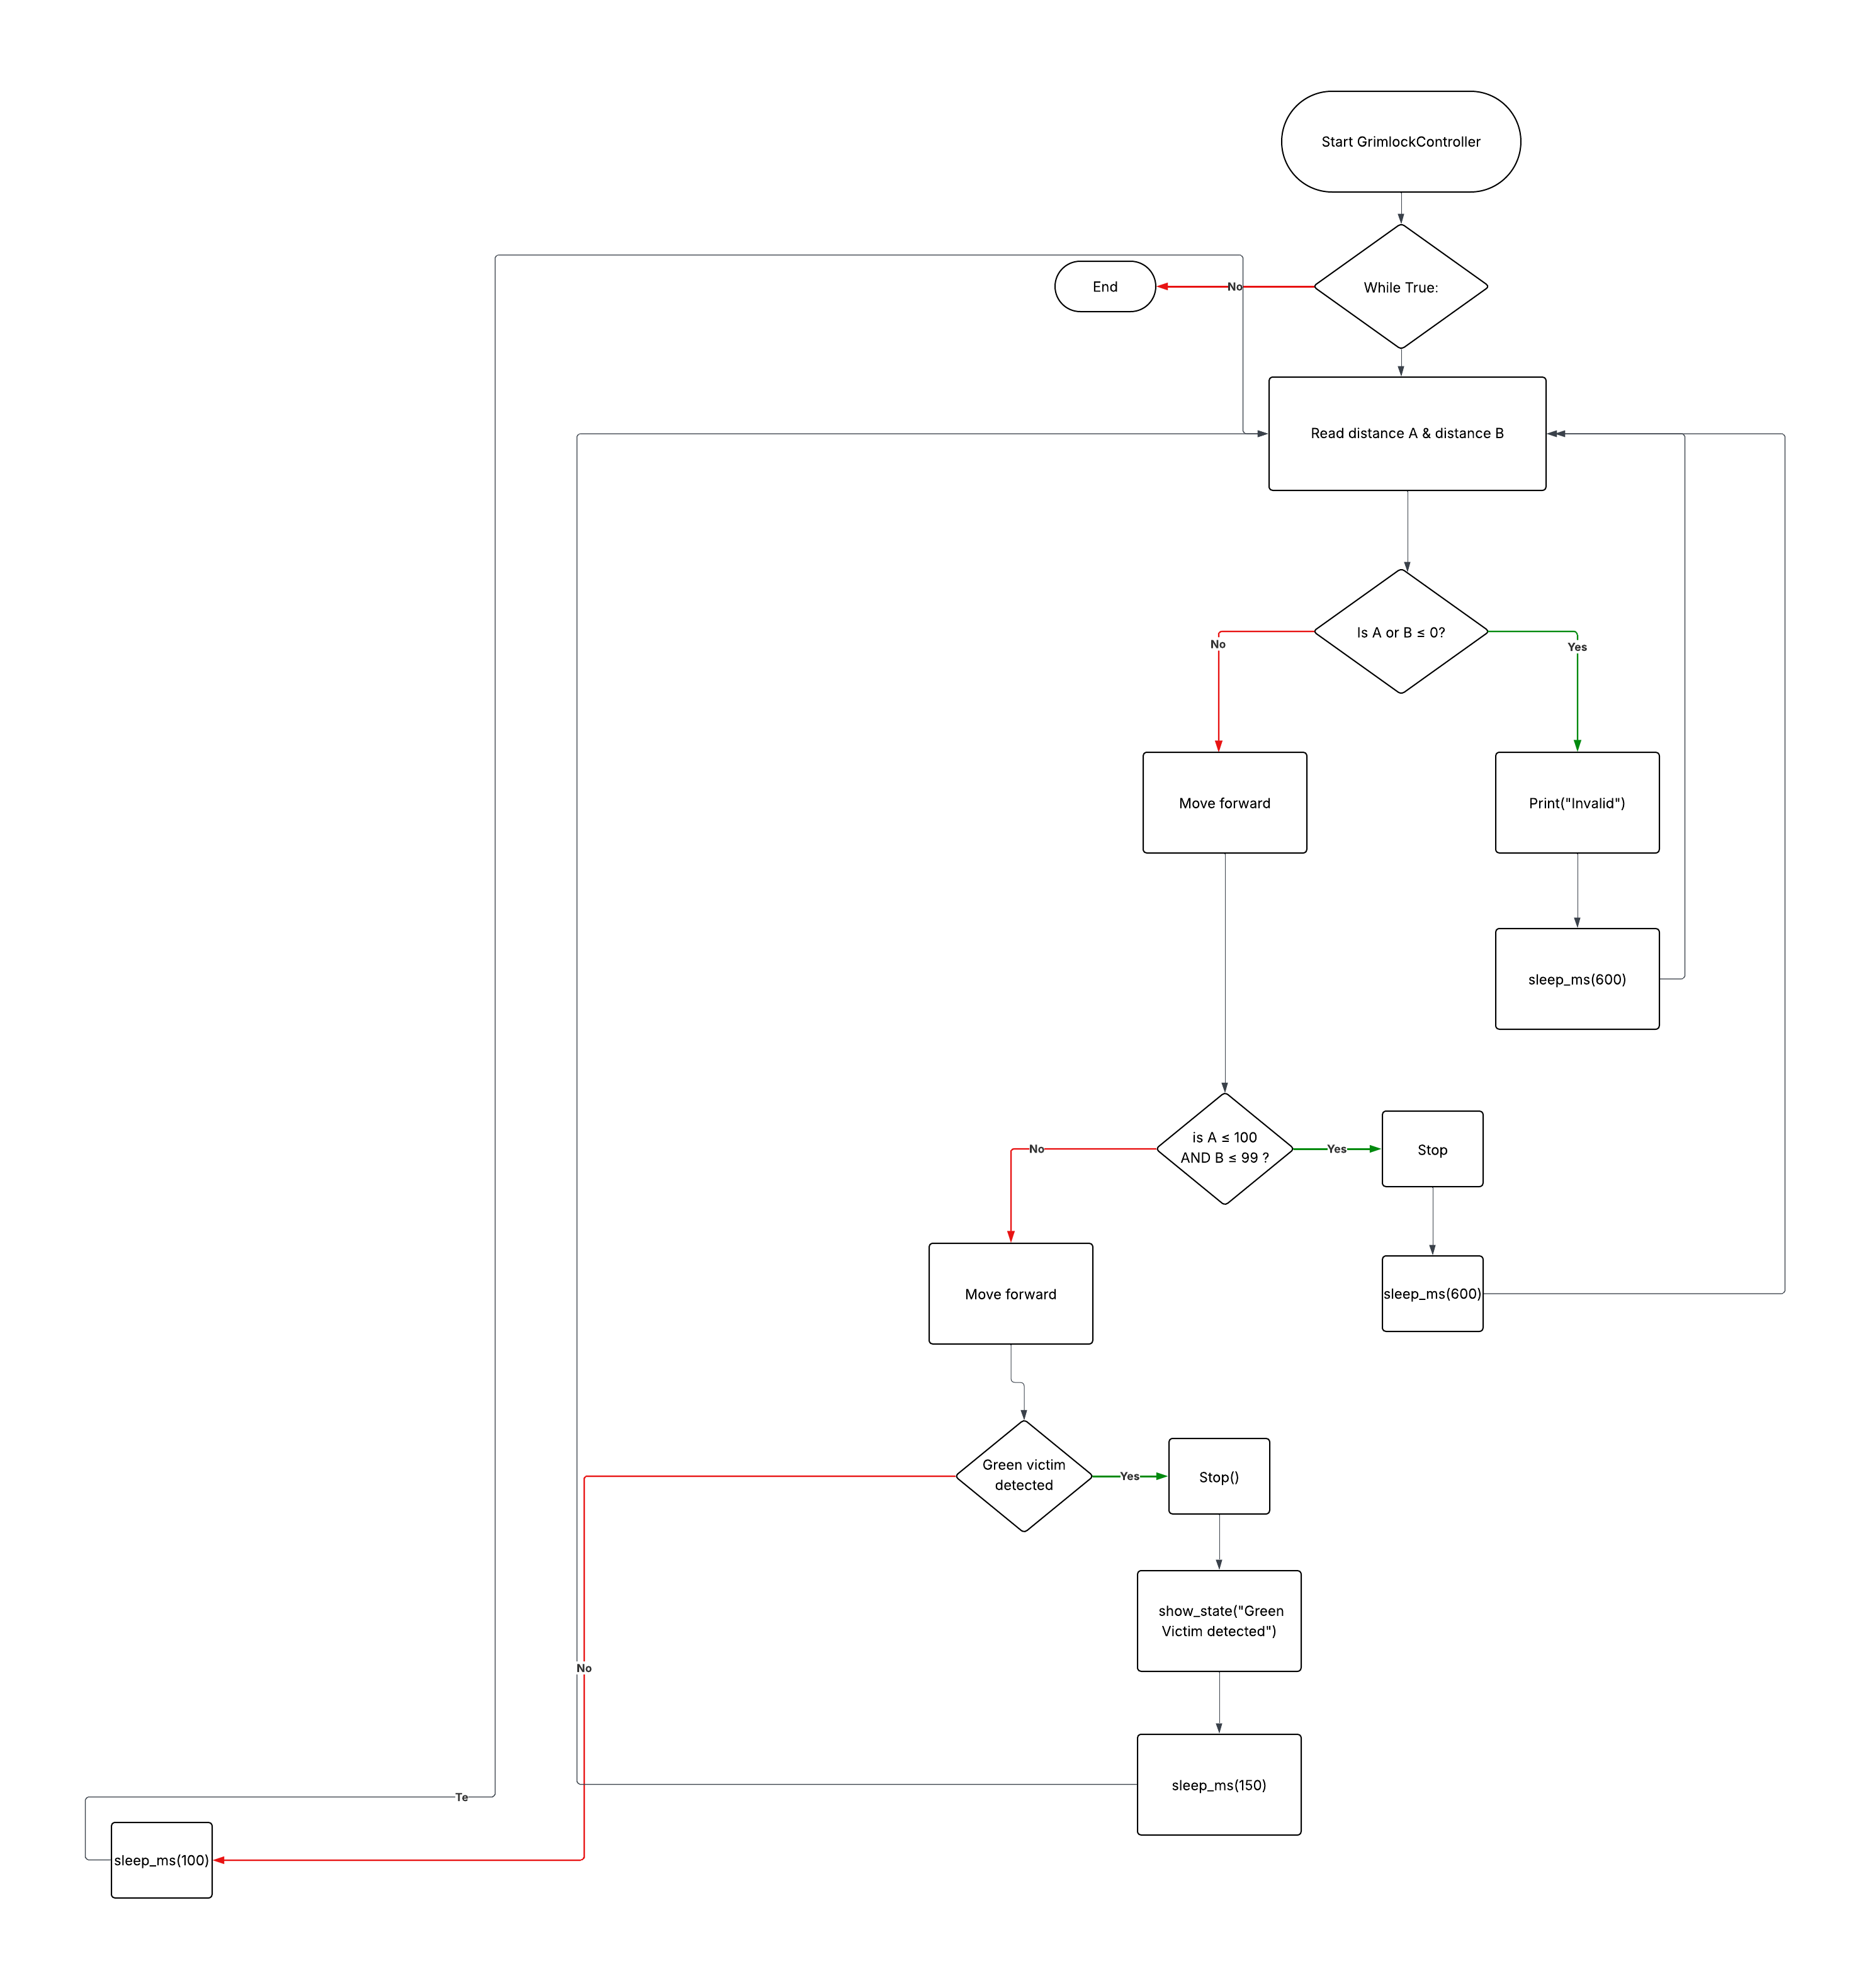

Wiring diagram:

Material components list

* 2x Servo Wheels
* Arduino Uno
* HC-SR04 Ultrasonic Sensor
* 5 Channel Digital Line Finder or 1 or more Digital/Analog Line Finder
* Dupont Cables
* 2x 3.7v 18650 Polymer Lithium Ion Battery
* 2x LiPo holder
* XL4015 DC to DC Converter Module (alternative to use Diodes in series)
* 5x20 PCB Fuse holder
* 5x20 fuse
* 2x 100µF 25v capacitors
* Wood
* 4x male to male wires
* 4x male to female wires

**Power supply calculations**

|  |  |
| --- | --- |
| **Battery pack** (2x 3.7V):  7.4V | **2 capacitors** (step down of ~0.5V each)  7.4V -> 6.4V |
| **Servos**  5V received | **De amplifier** (down to 5V)  6.4V -> 5V |

**Testing and Evaluation**

|  |  |  |
| --- | --- | --- |
| **Unit Test Figure 1** | **Unit Test Figure 2** | **Class Figure 3** |
|  |  |  |
| **Class Figure 4** | **Class Figure 5** |  |
|  |  |  |

**Justification of the object-oriented programming technique**

**How has polymorphism, encapsulation, inheritance, and abstraction been applied to the figures above**

Figure 1

Encapsulation

* Servo object hides all PWM pin setup
* Move hides the sequence of servo action needed to go forward

Inheritance

* Servo inherited from the servo reusing the same setup logic

Polymorphism

* Move is designed to work with any motor like object

Abstraction

* Calls like movement.right() covers the servo angle timing

Figure 2

Encapsulation

* Colorvicitm, servo, move hider their own internal workings

Inheritance

* Servo inherited from the Servo class reusing the same setup logic

Polymorphism

* Move is designed to work with any motor like object

Abstraction

* High level calls like movement.forward() mask the complex servo and timing code

Figure 3

Encapsulation

* Servo, Move, PiicoDev_Ultrasonic, and colorvictim each hide complex hardware interactions

Inheritance

* Servo inherited from the Servo class reusing the same setup logic

Polymorphism

* Move is designed to work with any motor like object

Abstraction

* High level calls like movement.forward() and show_state mask the complex servo and timing code

Figure 4

Encapsulation

* Move bundles all movement behavior in one class

Inheritance

* Servo inherits behavior from the servo class

Polymorphism

* Move accepts any servo‑like objects that implement. set_duty() and .stop().

Abstraction

* Hides the high level code e.g .forward()

Figure 5

Encapsulation

* Wraps all the logic for reading the color sensor and determining the green victim

Inheritance

* PiicoDev_VEML6040 handles low‑level I2C communication and RGB data reading.

Polymorphism

- Any sensor class with a .readRGB() method returning the same data format could be plugged in

Abstraction

* -.greenvictim() is a simple, high‑level action name that hides the details of threshold